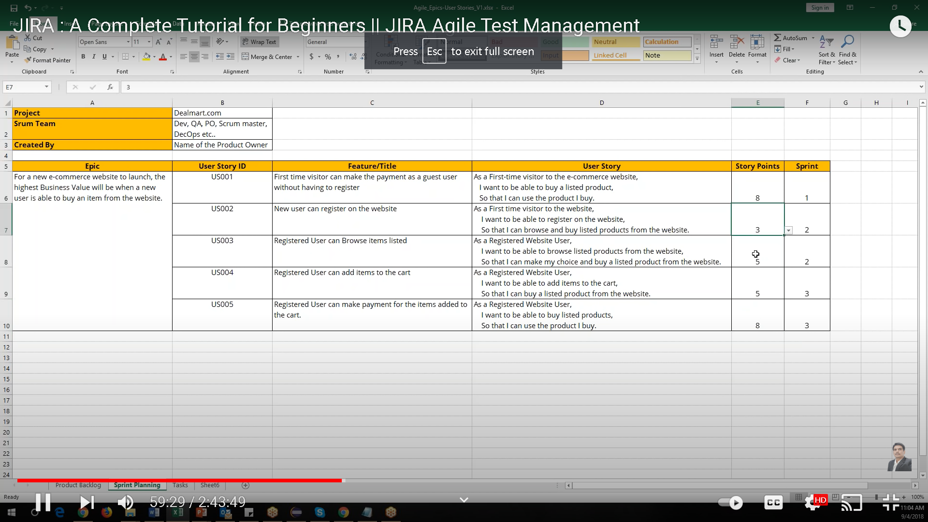Product BAcklock
